Exhibitions proposal - Benson gallery, English Faculty Library
The library welcomes proposals for exhibitions from current students, staff and alumni of the Faculty of English and Department of Anglo-Saxon, Norse and Celtic, at the University of Cambridge.
The primary aim of the exhibition should be to share the outputs of academic research with a wider non-specialist audience. The content may relate to language and literary themes, historical, cultural, and interdisciplinary topics and those topics with a relationship to library collections are encouraged.
Exhibitions may last from 4 weeks to one full term, depending on demand for the space. Your application should state if a particular date is preferable.
The ‘call for proposals’ is now open. Members of the library committee will meet each term to consider proposals, with applicants informed of the outcome shortly after each meeting.
A stipend of £100 will be awarded to students at the Faculty of English, to compensate for your time working on the exhibition. There may also be limited funds (max £50) to buy relevant books and help with printing costs. The library can assist with marketing the exhibition for example through social media channels and faculty mailing lists.

About the Space
The room is located near to the entrance of the library, it has no natural light and is a through space with no doors. The room has limited wall space where posters can be displayed and a digital screen is available for use, this can be linked to a laptop. There are four display cases which can be used to house books or objects, these are not secure, therefore we do not recommend anything of value is included in the exhibition. We recommend that proposers visit the gallery space before submitting their application.
The Benson gallery is open to the public whenever the Library is open.

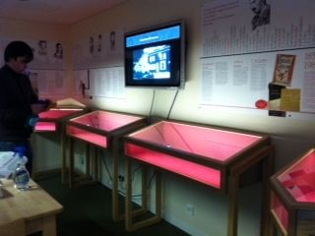

Please forward any queries to Laura Moss, English Library Manager at lm810@cam.ac.uk.
Exhibition proposal form for the academic year 2023/2024
Please return this form to english@lib.cam.ac.uk
Name

Email address

Are you?
-UG student
-Masters student
-PhD student
-Staff
-Alumni

Title of exhibition
Please provide a summary/description of the exhibition – what is the research about? What will be the content of the exhibition?
(max 300 words)

Preferred dates | Michaelmas /Lent /Easter
Is the content suitable for all audiences? (Is there anything that could potentially offend?)

